The Economy:

- The Economy has consistently ranked the top issue for voters in the 2024 Presidential Election.
  - Does any candidate have an actual sound Economic policy?
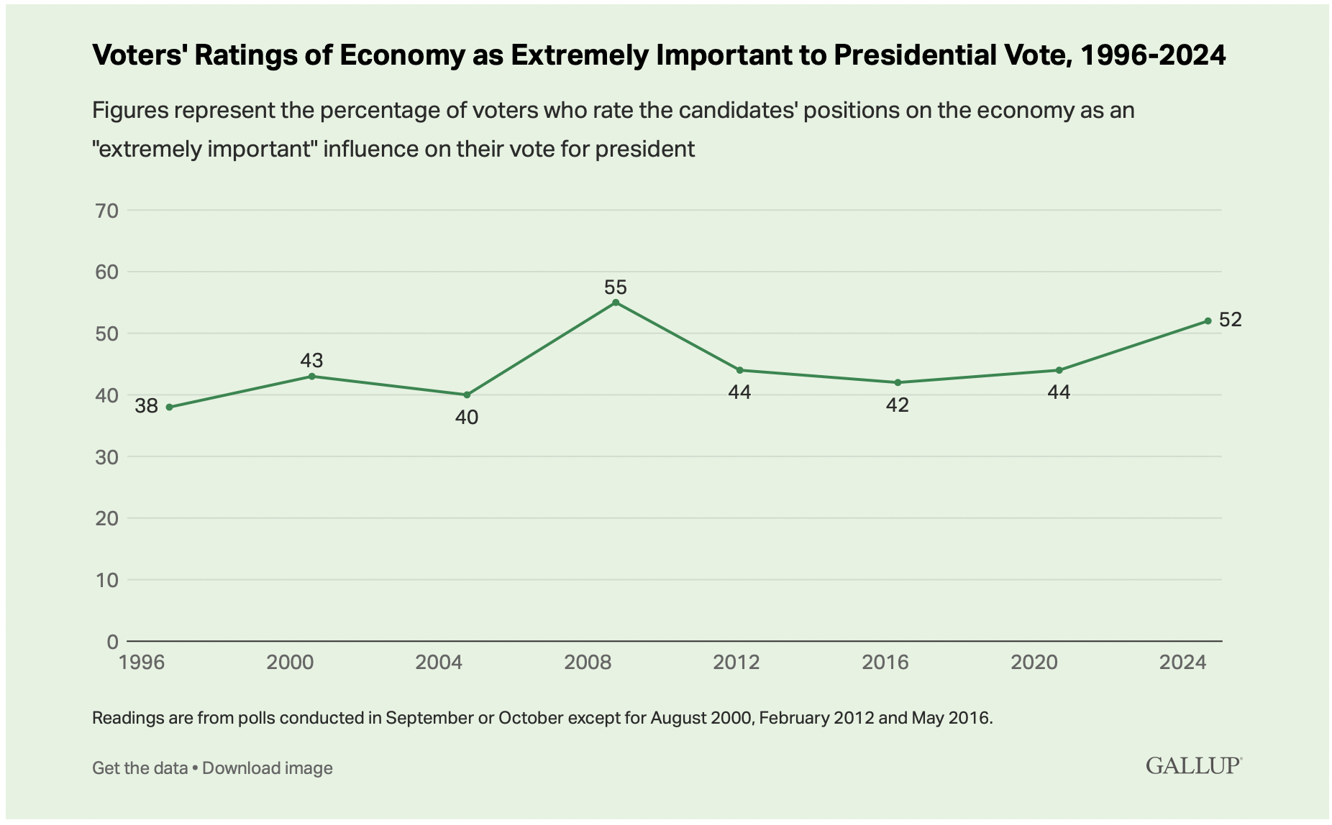

Unemployment:
Since the early days of the Pandemic the United States has been rocked with record high unemployment.
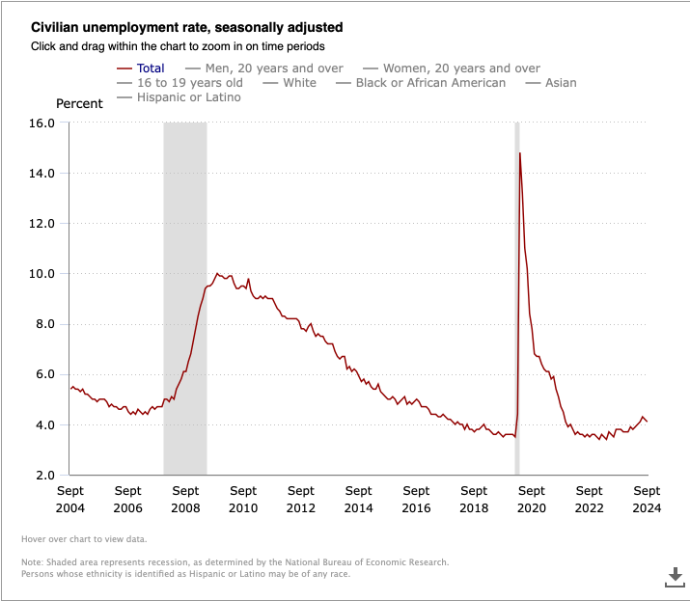

- Kalama Harris insists unemployment isn’t an issue quoted in a 60 Minuets interview “America is at a record low unemployment”.
  - The recent jobs report does show a slow in unemployment, yet Republicans are using high inflation and record high gas and food prices to nail Democrats.

- Donald Trump had one of the lowest unemployment rates while in office. He insists that bringing back American manufacturing to places like Michigan, and other Midwest states will bring jobs and lower America’s reliance on China and other manufacturing nations.

- Is unemployment that big of an issue?
- Is bringing back manufacturing an actual solution?
- Can Democrats celebrate low un-employment?

Inflation:
What is Inflation?
Inflation is a sustained increase in the prices of goods and services, and it can be caused by many factors, including:
- Supply shocks
- Disruptions to production, like natural disasters, or increased production costs, like high oil prices
- Demand shocks
- When demand for goods and services exceeds the supply, like when a government increases spending or a central bank lowers interest rates
- Monetary policy
- When the money supply grows too quickly relative to the size of the economy
- Inflation expectations
- When households and businesses think prices will increase in the future, which can actually cause prices to increase
- Built-in inflation
- When workers demand higher wages to keep up with rising living costs, which causes businesses to raise prices to offset the wage increases
Central banks, like the Federal Reserve in the U.S., monitor inflation and try to control it by raising interest rates
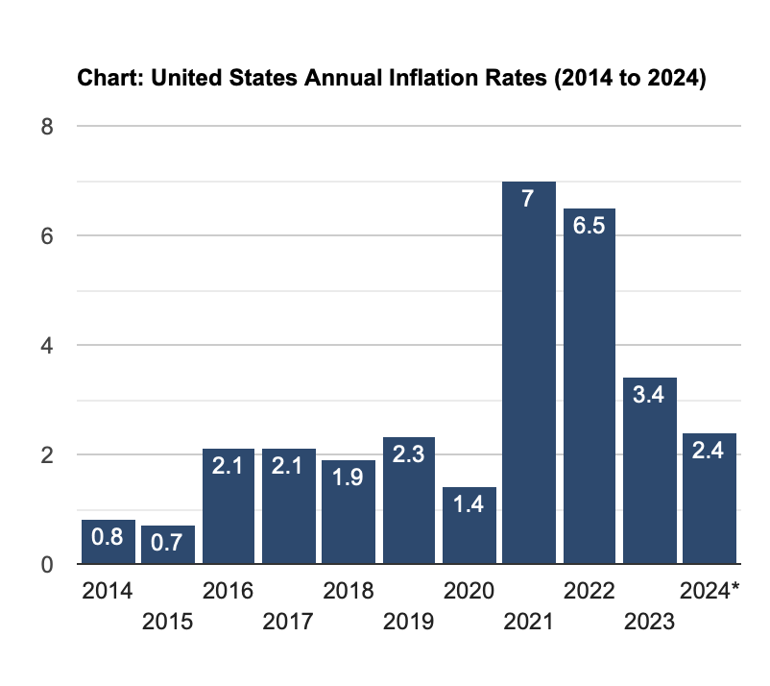
- Inflation skyrocketed during the pandemic as rising costs of shipping and doing business led to higher costs for food and other basic necessities.
- The Russian Invasion of Ukraine also heavily impacted energy costs, from gas to natural gas used to heat homes.
- The Federal Reserve has recently cut rates for the first time since before the pandemic giving signs of a healthy economy.

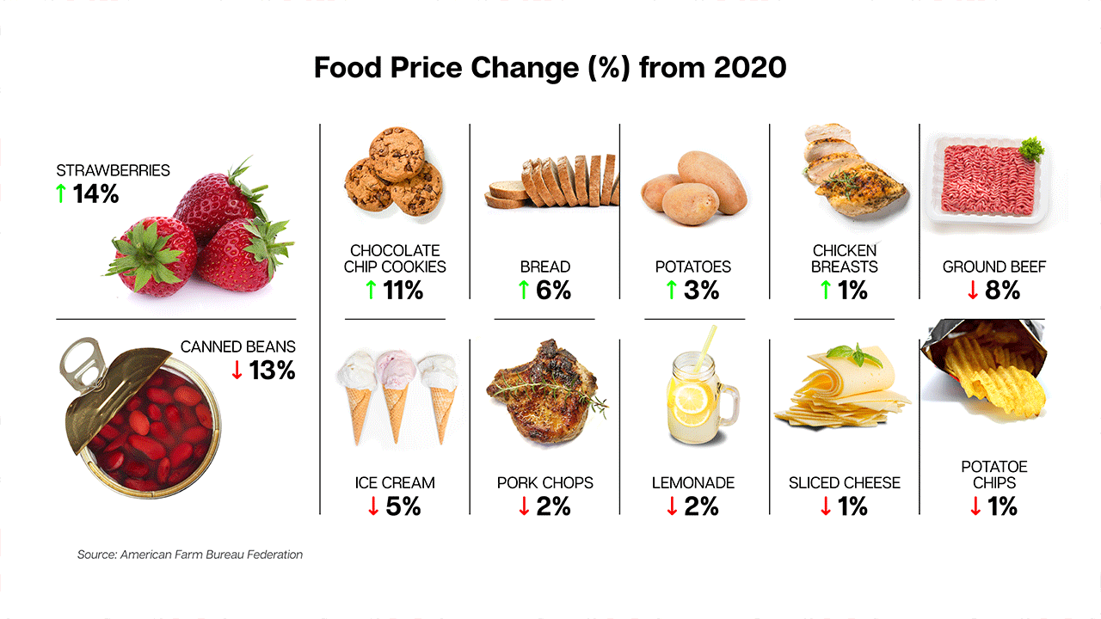
- Donald Trump has suggested a 20% tariff on all imports into the United States, he claims this will end China and other countries from “ripping off American consumers”. Economists say this will only cause higher prices on basic goods, already worsened from current inflation.
- Trump has also suggested ending the Fed’s political independence, giving the President more direct power over the Economy. Experts say this will be detrimental to our Democracy, ending the independence gained sine the era of the Founding Fathers.
  - Should the Fed remain independent?
  - Is a 20% tariff a good idea?

- Kamala Harris plans to fight companies directly. Promising to use the DOJ to fight corporations that set food prices for “price-gouging” and anti-monopoly lawsuits.
  - Will this work?
  - Is this just a repeat of Biden’s work with drug prices?
National Debt:

- Neither candidate has given any space to talk about the rising National Debt.
- The United States Federal Government has had to avoid a shutdown multiple times by raising the debt ceiling.
- Economists say both of their policies will only aid the debt.
- How can we avoid even more debt?
- Is the USFG bound to fail each time we raise the debt ceiling?3

